

Church Sound Setup

Step by Step guide to setting up and connecting the sound equipment needed for Sunday Service.

Table of Contents
Turn On Equipment in Drum Room 4
Disconnect Current Setup 5
Reconnect Cabling to Inner Ear Transmitter 5
Load Saved Stage Setup into Aviom 6
Power Up Remaining Equipment 7
Apply Power to Equipment Rack in Sound Room 7
Apply Power to Sound Board 7
Sound Board Initial Setup 8
Load Redemption Scene into Board 8
Set Sound Board Initial Levels 8
Locate the Equipment Bag 9
Battery Tester 9
Check the Batteries of the Handheld Wireless Mic’s 10
Check the Batteries of the Inner Ear Packs 10
Check the Batteries of the Wireless Mic Pack 10
Place Checked Equipment Up Front 11
Connect the Piano Mic 11
Locate the Wired Shure Microphone and Cable 11
Connect the Microphone and place in Mic Stand 12
Verify Piano Connections and Turn On 12
Live Stream Audio Connection 13
Connect Headphones if needed. 14
End of Service Shutdown Checklist 14
Gather up the Equipment and Return to Bag 14
Sound Board for Shutdown 15
Retrieve Equipment from Stage 15
Power Down Drum Room Equipment 15
Return Cables back on top of Drum Room 15
Return Equipment Bag 15

Turn On Equipment in Drum Room
Go inside the Drum Room and locate the Blue power switch located in the upper right of the rack of equipment at the back of the room. This will also apply power to the Dual Wireless microphone Transmitter that is also located inside the Drum Room to the left.
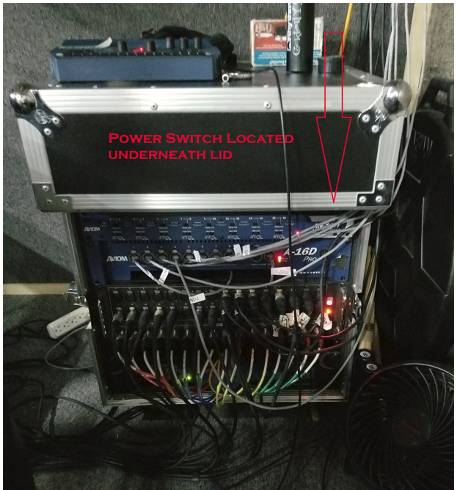
Inner Ear Power Pack Setup

Disconnect Current Setup
Grab a chair or stool and carefully climb up the back side of the Drum Room and look over on top. Locate the Brazilian Churches wireless microphone transmitter to the left and disconnect the XLR cable, marked with a green band, from the back of it.
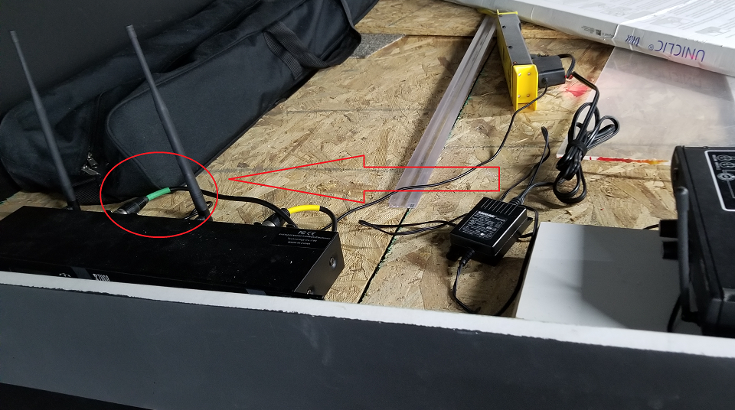

Reconnect Cabling to Inner Ear Transmitter
Connect the now loose XLR cable (green band) to the front of the Inner Ear transmitter located just to the right. Then, located in the back of the transmitter, reconnect the power to the back of the Inner Ear transmitter and verify the front lights illuminate. The power strip will power up once the Drum Room equipment rack is powered on (previous step)
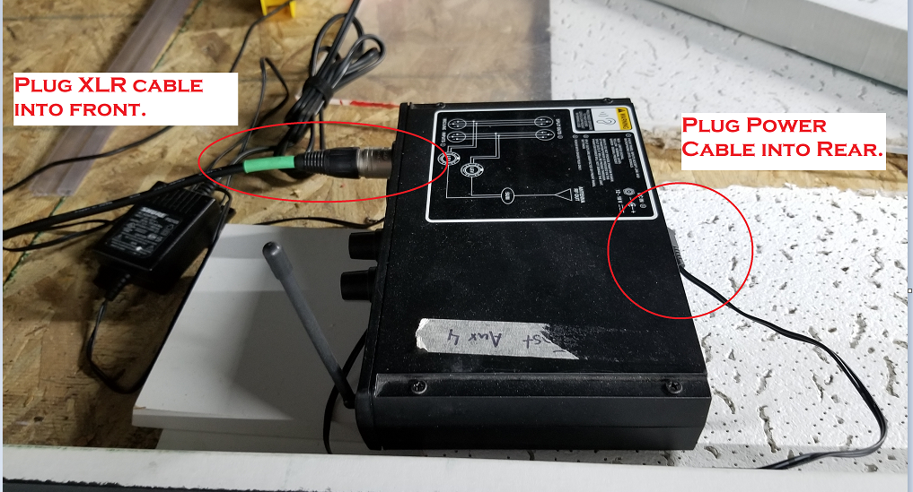

Load Saved Stage Setup into Aviom
Climb down from Chair and locate Aviom Mixer box located on the stage (should be right below where you climbed down) labeled “Miller” and verify a green banded cable is plugged into the back. Connect if not.
From the AVIOM controls, press the “Recall” button and then the Number “7” button to recall our unique stage setup.
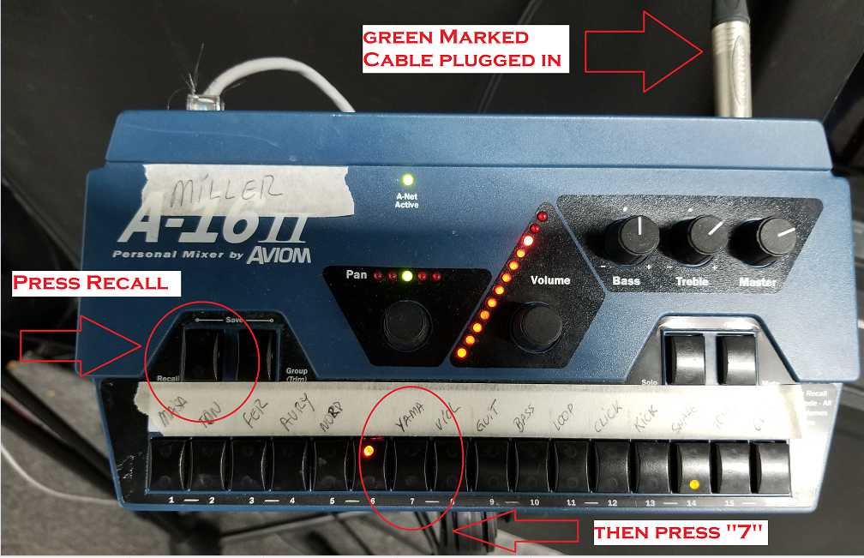

Power Up Remaining Equipment

Apply Power to Equipment Rack in Sound Room
Return to Sound Room and locate the Red Power Switch for the Equipment Rack located underneath the Sound Board and turn in ON. This will apply power to the Main Amplifiers and Sound Board.
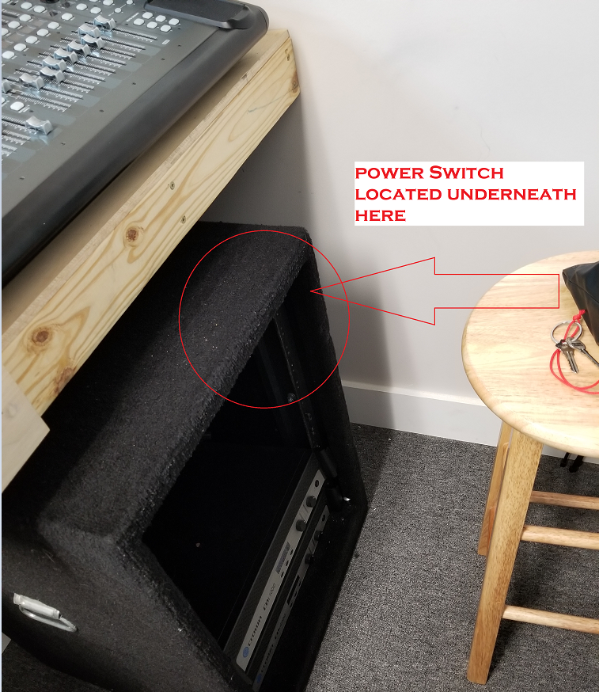

Apply Power to Sound Board
Remove the dust cover from the top of the sound board, roll up and place to the side. Reach around to the back right rear corner and flip the power switch of the Sound Board to ON.
REMEMBER SOUND BOARD is ALWAYS LAST to be TURNED ON and is the FIRST to be TURNED OFF when Powering down.
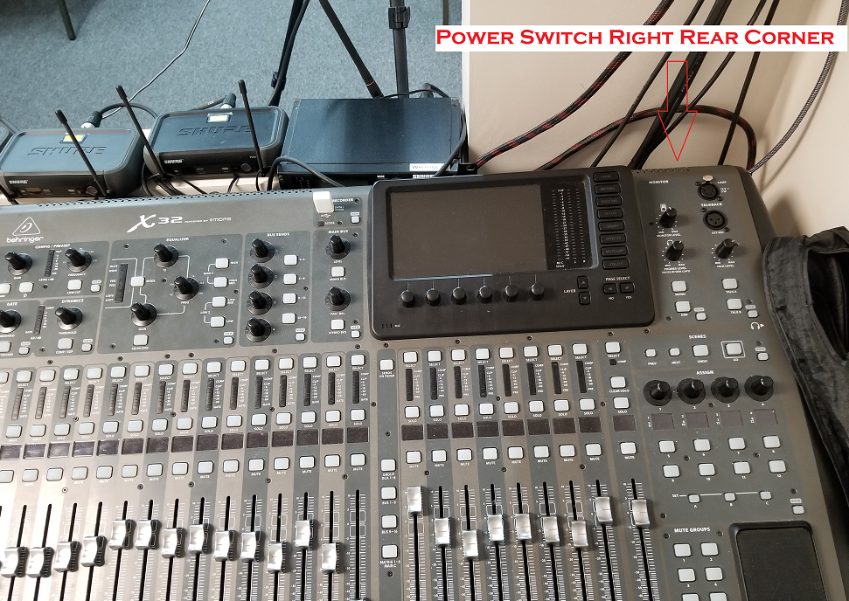

Sound Board Initial Setup

Load Redemption Scene into Board
On the Sound Board, locate the “Scenes” section (right side of the board) and press the “view” button until its illuminated and the display shown is similar to the example below.
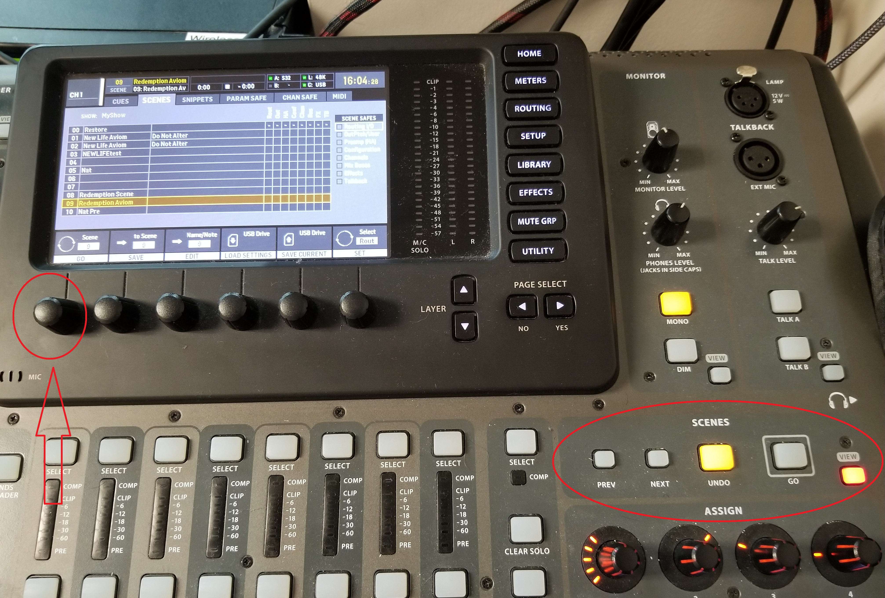
- Rotate the “Scene” knob until Saved location #9, “Redemption Aviom” is highlighted and then depress the same knob followed by then pressing the “Page Select” Yes to load the saved setup.
- Press the “Home” button located along the right edge to return to general display.

Set Sound Board Initial Levels
- Initially the inputs to the Board will be set to MUTE as denoted by the MUTE buttons being illuminated RED. Unmute each one as needed during sound check.
- Next, place the “MAIN” output volume slide upward to @ -10 db to start with. Generally, this will be a good place to start out at.
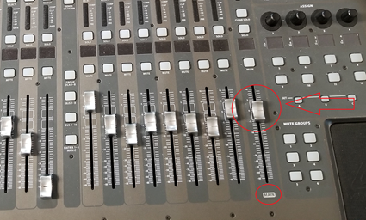

Locate the Equipment Bag
Retrieve the Equipment bag from the Storage Closet and bring it into the Sound Room.
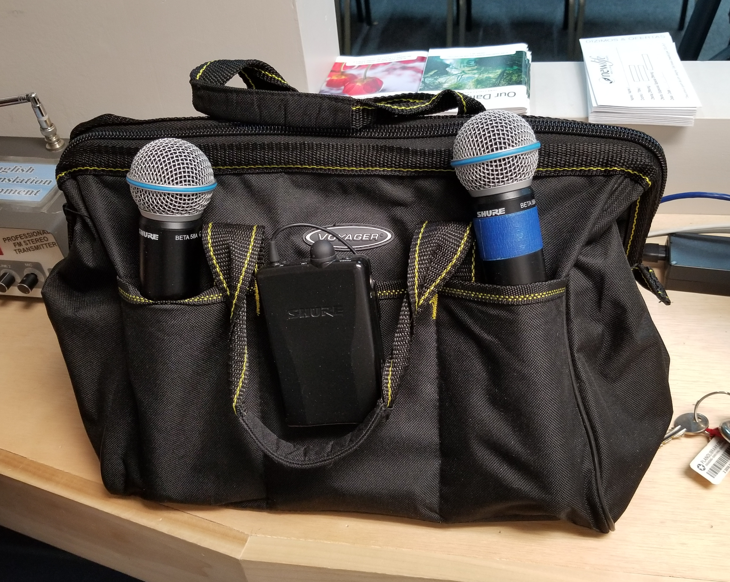

Battery Tester
Open the bag and find the battery Tester, generally in one of the inside pockets.
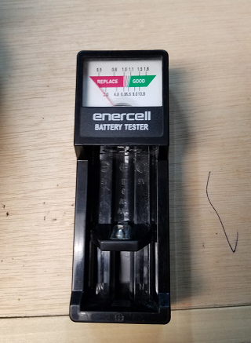

Check the Batteries of the Handheld Wireless Mic’s
- Remove the two handheld Wireless Microphones from the side of the Equipment bag and by spinning off the bottom cover of each, remove one of the AA batteries (no need to check both) and check with the Battery Tester. Replace both if battery tests low or even marginal.
- Reinstall each bottom cover afterwards and turn each one ON and after unmuting “Input 25” and “26”, test each for operation. Turn OFF after completion.

Check the Batteries of the Inner Ear Packs
- Remove the three Inner Ear Packs clipped to the side of the Equipment bag and by removing the bottom cover, remove the single 9-volt battery and check with the Battery Tester. Again, replace if battery tests low or marginal.

Check the Batteries of the Wireless Mic Pack
- Remove the small beige box from inside the Equipment bag and open it to get the Wireless Mic pack from inside. Flip the door open and remove one of the AA batteries and check with the Battery Tester. Replace both if battery tests low or marginal.
- After completion, closed the battery cover and temporarily connecting the microphone.
- Looking at the back of the Sound Board, carefully disconnect the XLR cable from IN 28 and move it and connect to IN 3.
- Now unmute #3 “Pastor Mic” and test to ensure it works. Turn OFF upon completion.
Remember at the end of the service to move this connect BACK to #28 to avoid trouble with the other Church.

Place Checked Equipment Up Front
After checkout, place the two handheld wireless microphones, the Wireless Mic pack and microphone and the three Inner Ear packs on the front row for the musicians to pick.
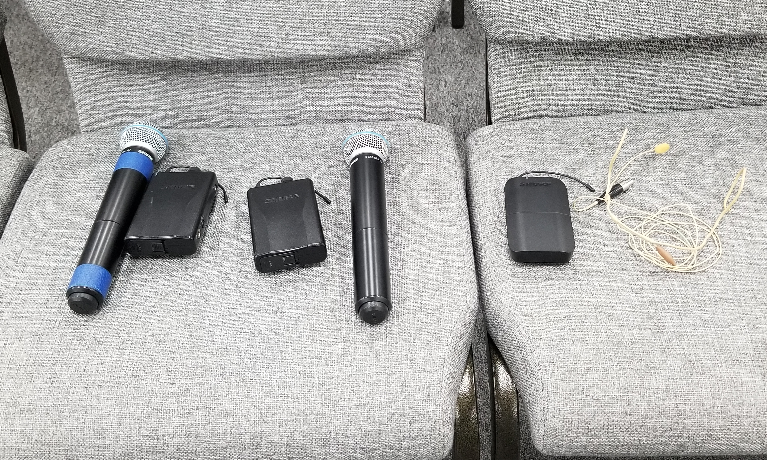

Connect the Piano Mic

Locate the Wired Shure Microphone and Cable
Locate and remove the Wired Shure Microphone from one of the side pockets and the XLR cable from the Equipment bag and carry to the stage.
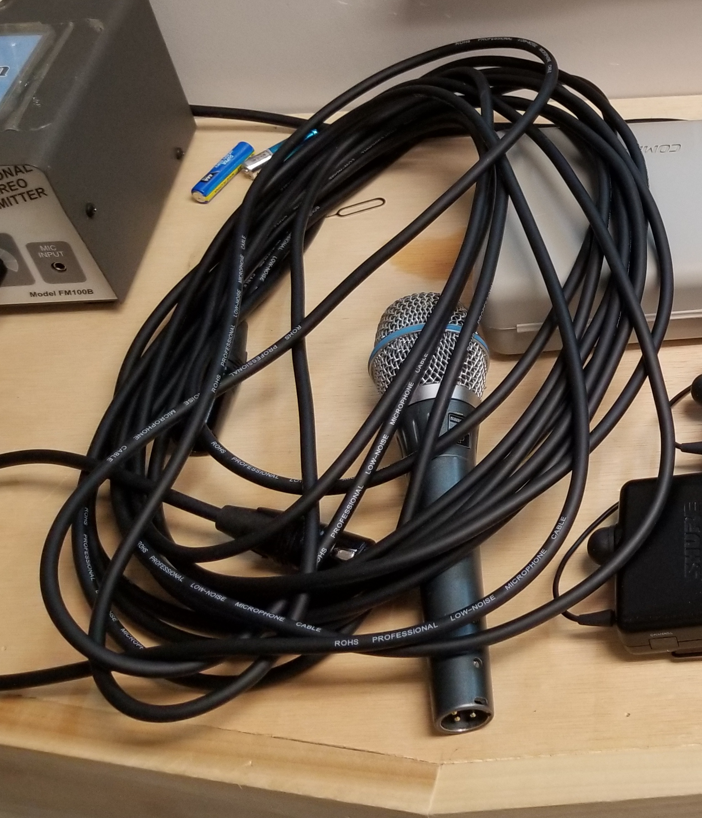

Connect the Microphone and place in Mic Stand
- Connect the Microphone to the XLR cable and then place the Microphone in the Mic stand that should be in front of the Piano and then route the cable along the left side and around to the back, middle area of the stage.
- Locate the short XLR cable coming out thru the stage that might be connected to either a direct box (Acoustic Guitar) or possibly another XLR cable and microphone. Disconnect from either and connect this microphone to this connection from the stage floor. Wind up and make nice the other disconnected cables as needed.
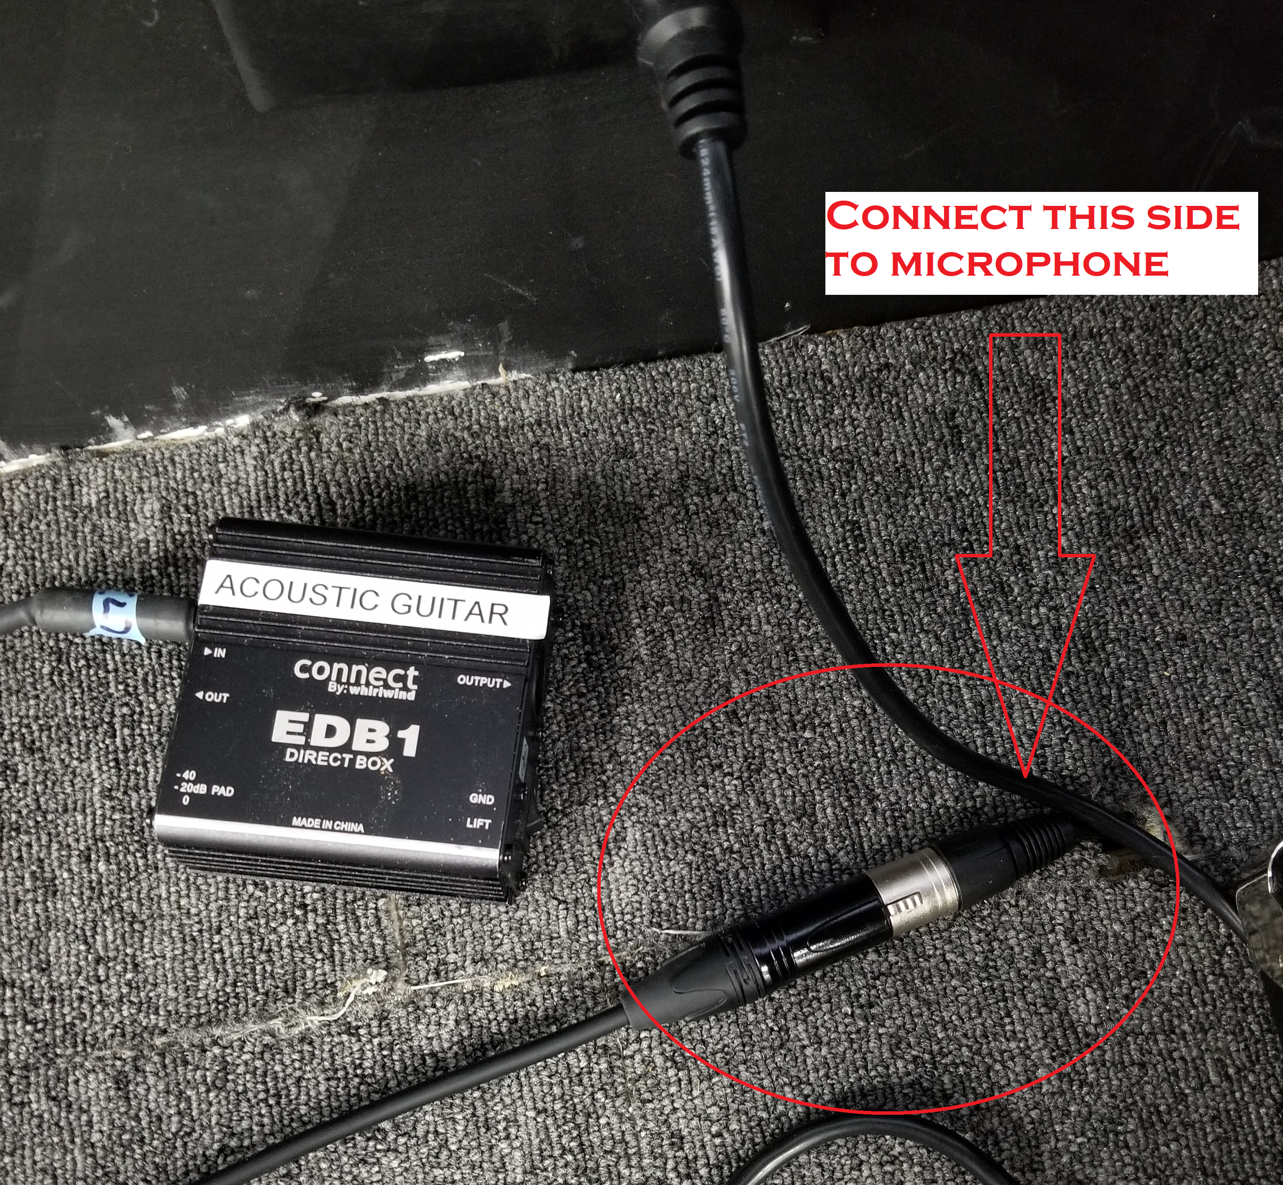

Verify Piano Connections and Turn On
- Check the back of the Piano to see that the connections are made (locate and connect if not) and then Turn ON piano (switch to far left of this view).
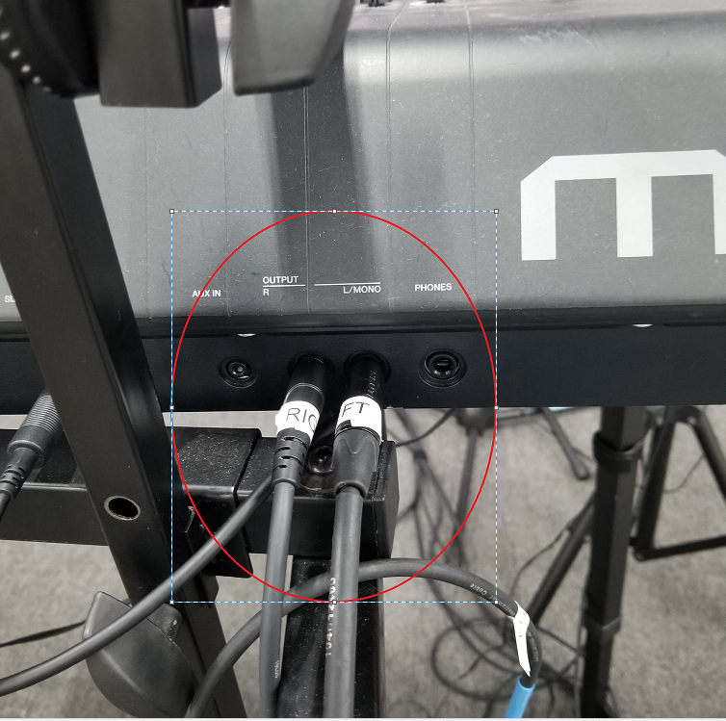
- Go back to the sound board and unmute the Piano and the Piano Mic and then test both to ensure working. Re-mute Piano Mic on Sound Board once done.

Live Stream Audio Connection
- Locate the long 1/8 Mini to RCA Jack cable from the Equipment Bag.
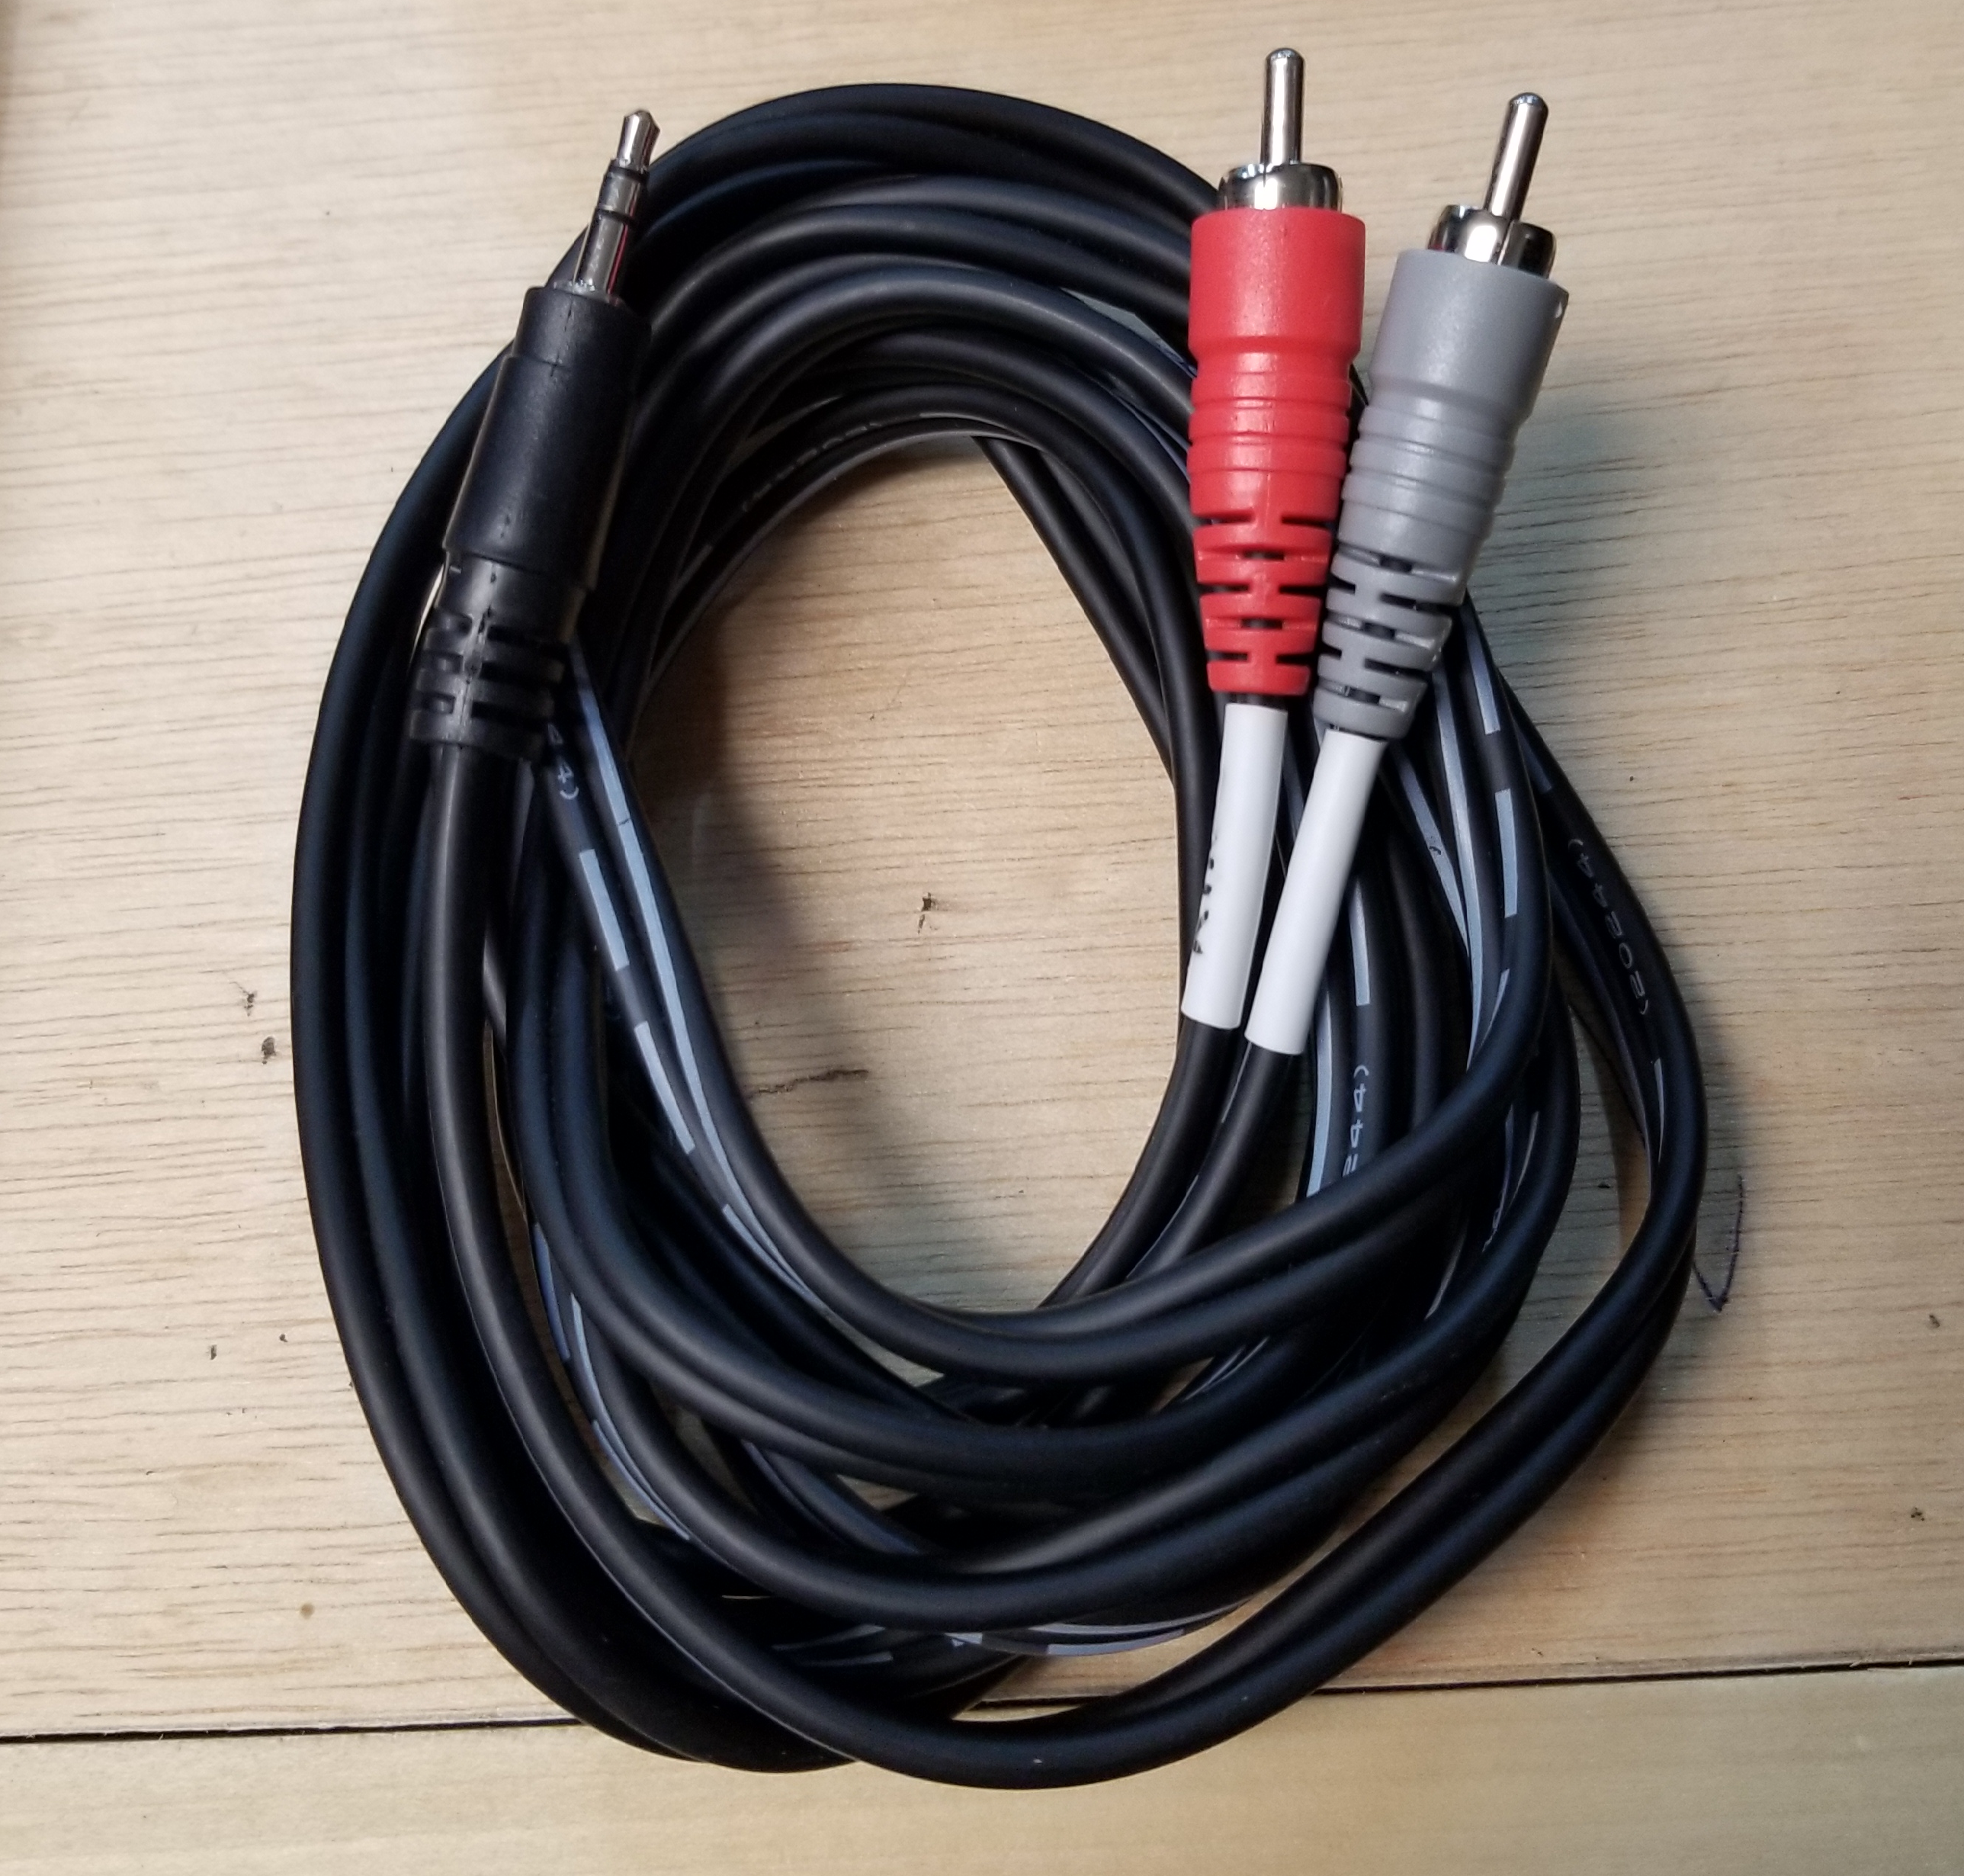
- Unwind and connect the RCA Jacks to the back of the Sound Board at the Aux 6 Input jacks (Red to Red, Grey to White).
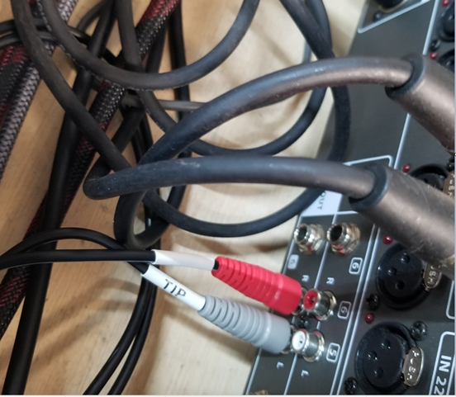

- Connect the 1/8 Mini Jack to the back of the ATEM Microphone #1 input and press the ON button of Mic1 to illuminate.
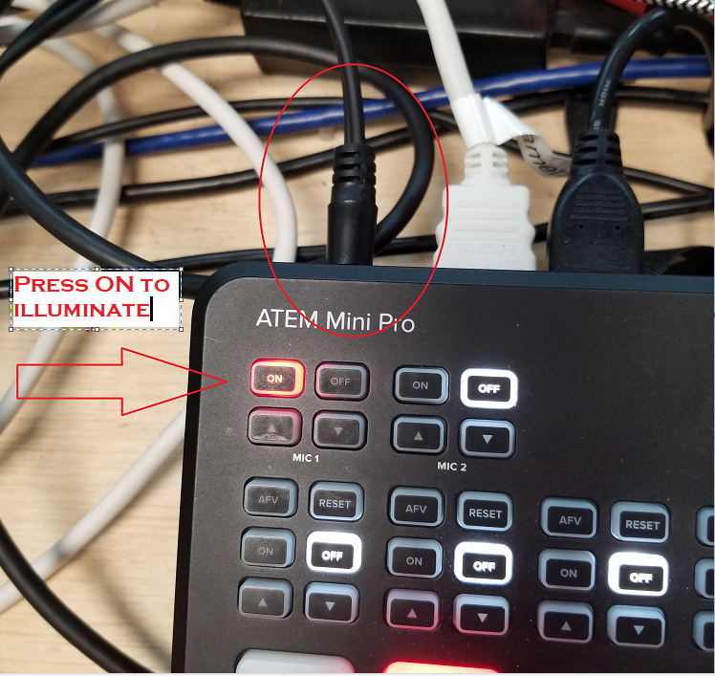

Connect Headphones if needed.
Remove the Y cable, headphones and extender cable and connect if needed.

End of Service Shutdown Checklist

Gather up the Equipment and Return to Bag
- Locate the two handheld Wireless microphones, the three Inner Ear packs and the Wireless pack and microphone to be placed back in the Equipment bag.
- Place the handhelds in the outside pockets of the bag, and clip the packs to the pockets.
- Place the Wireless pack and microphone back into the beige box and then place the box inside the bag.
- Disconnect the Live Stream Audio cable from the back of the ATEM and Sound board and wind up and place in an inside pocket of the Equipment bag.
- If used, wind up the headphone extender cable and place the headphones, Y adapter and the extender cable in the Equipment bag.

Sound Board for Shutdown
- Move the XLR cable that is at #3 input back over to #28 on the back of the Sound Board.
- Reach around to the right, back side and flip the Sound Board switch to OFF.
- Place the Dust cover back over the Sound Board.
- Reach for the Red switch located on the Equipment rack under the Sound Board and Turn OFF.

Retrieve Equipment from Stage
- Remove the Wired Shure microphone from the mic stand and then coil up the XLR cable, placing the mic in an outside pocket and the cable inside.
- Reconnect the XLR cable at the back of the stage just as it was previously configured, either connected to the Direct box, mic cable or neither.

Power Down Drum Room Equipment
- Enter the Drum Room and Turn OFF the Blue switch located on the equipment rack.

Return Cables back on top of Drum Room
Climb up and return the cables back to their original locates and remember to disconnect the power cable from the back of the Inner Ear Transmitter.

Return Equipment Bag
Double check that all equipment removed from Bag has been returned and then return Equipment bag to storage closet.

