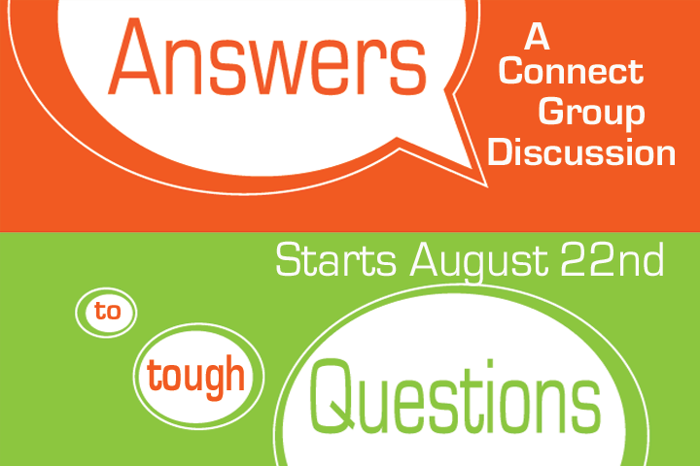
Got a Question? Let’s hear it!

Got a Question? Let’s hear it!

Got a Question? Let’s hear it!

Got a Question? Let’s hear it!

Got a Question? Let’s hear it!

Got a Question? Let’s hear it!

