OPTICAL ILLUSION PACK

Directions: Hand out the following packet to each group. Have preteens work together in groups and determine the two answers to each image. Each image (except #6) has an obvious answer and a not so obvious one. The below answers are for your purposes only, so be sure to delete them before handing them to students.

- What do you see in the below picture?
________________________________________________________________________________________

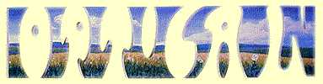
Answer: You may not see it at first, but the white spaces create the word OPTICAL, while the blue landscape spells out ILLUSION.

- What do you see?
________________________________________________________________________________________

Answer: The word Teach is on the top and Learn is beneath it.
- What do you see?
________________________________________________________________________________________
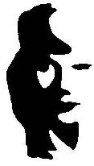
Answer: A woman’s face and a man playing the horn.

- What do you see?
________________________________________________________________________________________
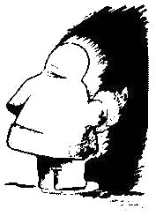
Answer: An Eskimo entering a cave and a profile of an American Native.

- What do you see?
_______________________________________________________________________________________
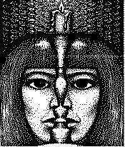
Answer: Two profiles facing each other and a lady looking at you behind a candles stick and candle.

- Which of the MIDDLE circles looks bigger? The one on the left or right?
________________________________________________________________________________________

Answer: They are both the same size.

