
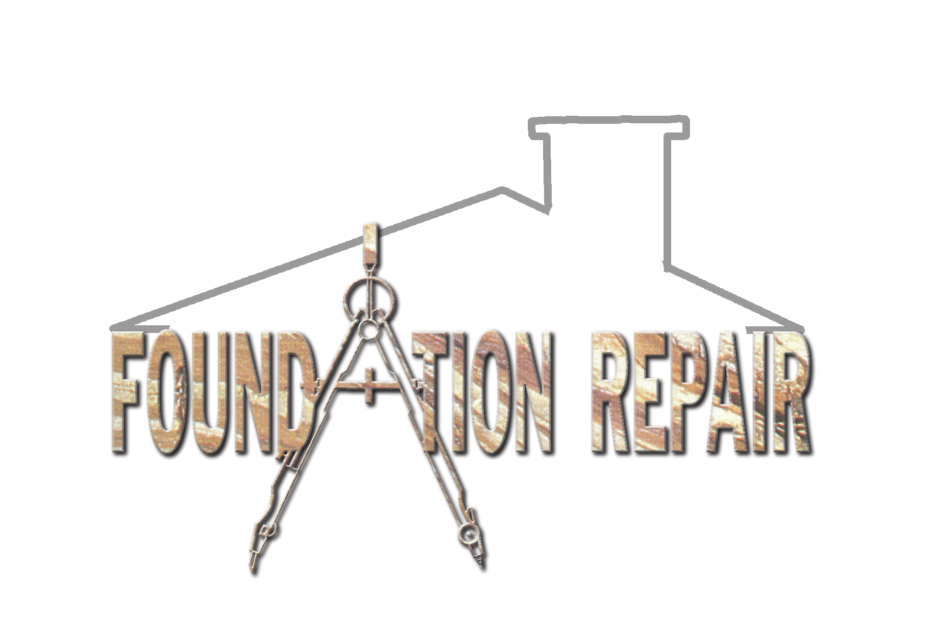
October 1, 2001

Dear

Since you are receiving this package it means that you have not yet registered for this years exciting marriage retreat., Foundation Repair.

In these unstable, uncertain times we are going to share with you some timeless truths that you can build an enduring relationship on. What’s more, we are going to give you a chance to hear from some people that have built just such a marriage.

The Marriage Retreat will be held in the Ramada-Plaza Hotel in downtown Ft. Worth. The hotel lobby and rooms have been newly renovated, and the rooms are very spacious. The hotel is located a few moments from Sundance Square and is directly across the street from the Ft, Worth Water Gardens. A trolley stops at the rear exit of the hotel and will take you to all parts of the city.

The cost is $189.00 per couple. This includes two nights stay and lunch on Saturday. Payment is due the day the retreat starts, and we do accept Mastercard, Visa, and American Express. Each year generous people give me extra money to help someone go to the retreat that otherwise may not be able to go. If you would like to help someone, or if you need some help please let me know.

The dates are November 9, 10, and 11. The first session will be at 7:30 p.m. on Friday the 9th. The retreat will end at 12:00 p.m. on Sunday the 11th. We have scheduled a large block of free time Saturday afternoon and evening for you to enjoy the numerous attractions of the Ft. Worth area.

I do hope you will be able to attend. I am 100% certain you will not regret it.

Sincerely,

Kevin Burgess

PS. I have included some materials about the great Ft. Worth area to better help you plan an exciting weekend. We are scheduling plenty of free time on Saturday evening for you to enjoy the city.

