Jesus in the Tabernacle 1 – Dwell
• GOALS & GUIDELINES:
• ICEBREAKER: Tell us why you LOVE or HATE camping…
• AGREEMENT PRAYER
- PRAISE
• SCRIPTURE READ

Over the next weeks we will be studying “the tabernacle.” Q- What is the tabernacle and why do you think it is worth talking about?

In the Hebrew scriptures of your Bible, it tells us of the tabernacle. This is the point in Israel’s history, where they had been delivered from slavery in Egypt, and at the time when Israel wandered in the wilderness. As God gave the law to Moses, He also instructed Moses to build something brand new – the tabernacle.

We read a portion of the instructions in Exodus 26. Q- Were the building instructions very specific? (yes) Q- What are some of the specifics? (dimensions & materials)

Hopefully you get the sense that the tabernacle was important to God. Exodus chapters 25-31 give the instructions for the construction of the tabernacle, the 6 important furniture pieces, as well as the adornment of the priests & high priest. Numbers chapter 2 gives specific instructions on how the 12 Israelite were to encamp around the tabernacle tent.

The name of our study is “Jesus in the Tabernacle,” because although the man Christ Jesus wasn’t to be born until approx. 1,500 years later, everything about the tabernacle reveals Jesus. So we should study the tabernacle because it #1. is important to God & #2. it reveals Jesus.

Q- How does the tabernacle reveal Jesus?

The revelation of Jesus in the Tabernacle is clearly stated in John 1:14. He says that Jesus, the Word, became flesh and made his DWELLING among us. The Greek word for dwelling is skēnoō, which means “abide (or live) in a tabernacle.” The Word became flesh and TABERNACLED among us. The tabernacle demonstrates the incarnation, where God would be become a human and dwell among man.

On the inside of the tabernacle are beautiful items. Curtains, gold, silver, bronze, impressive wood workings were found on the inside. Q- It was beautiful inside the tabernacle tent, but what does scripture say was visible from the outside? What was visible as a covering over the tabernacle? (Hint: Exodus 26:7 – Goat Hair curtains. **if brought up- There were other coverings as well – they were all unattractive materials**)

Although the inside of the tabernacle was beautiful, the outside of the tabernacle was not adorned. From the outside it looked like an ugly tent. The tabernacle had no beauty or majesty to attract us, nothing in its appearance that we should desire. Q- That should remind you of one of our scriptures we read tonight. What scripture? (Have the person who says Isaiah 53:2 read it aloud)

Isaiah 53:2 is describing Jesus. From the outside Jesus was not attractive. He was like the tabernacle covered in goat hair. Many people have looked at faith and not been attracted. Many have looked at Christianity and said ‘it is stupid and not the life for them.’ BUT IF ONLY they could get a peak of what is inside the temple? A life “in Christ” looks ridiculous to those on the outside, but to us who have seen past the curtains, it is beautiful! What we find INSIDE this tabernacle of Christ is everything we have been looking for. Q- Do you agree? Testify about something you have found inside Jesus that is beautiful.

Internal Q- Jesus wants to tabernacle with you. Will you allow him to be in the center of camp? Is Christ the center of your life? Have you recognized the beauty that is found inside Jesus? We are commanded to share the beauty of Jesus. Will you share that hidden beauty with the world?
VISION- The word became flesh and tabernacled among us. Center your life on Jesus this week.
Goals and Guidelines
- Grow in relationship with each other
- Grow in relationship with God
- Grow in number and multiply
- This is a non-denominational meeting where everyone's thoughts, ideas, and opinions are to be respected. Everyone is welcome and we encourage all to share their feelings.
- We will not argue or debate!
- We place God's Word as the highest authority.
- We all share equally in the ownership of this Connect Group, therefore we will all participate in hosting meetings from house to house on a weekly basis.
- We will be committed to attendance and arriving on time.
- When sharing, we follow 3 simple rules...
Stay on subject, Keep it short & Keep all comments appropriate.
- We will build confidence and trust with each other and become transparent.
- What is said in here stays in here. No gossip!
- Last but not least… We will invite others to our Connect Group!

John 1:14 NIV

14 The Word became flesh and made his dwelling among us.

Exodus 26:1-7 NIV
“Make the tabernacle with ten curtains of finely twisted linen and blue, purple and scarlet yarn, with cherubim woven into them by a skilled worker. 2 All the curtains are to be the same size—twenty-eight cubits long and four cubits wide. 3 Join five of the curtains together, and do the same with the other five.

4 Make loops of blue material along the edge of the end curtain in one set, and do the same with the end curtain in the other set. 5 Make fifty loops on one curtain and fifty loops on the end curtain of the other set, with the loops opposite each other. 6 Then make fifty gold clasps and use them to fasten the curtains together so that the tabernacle is a unit.
7 “Make curtains of goat hair for the tent over the tabernacle—eleven altogether.

Isaiah 53:2 NIV
He had no beauty or majesty to attract us to him, nothing in his appearance that we should desire him.

John 1:14 AMP
14 And the Word (Christ) became flesh (human, incarnate) and tabernacled (fixed His tent of flesh, lived awhile) among us

VISION- The word became flesh and tabernacle among us. Center your life on Jesus this week.

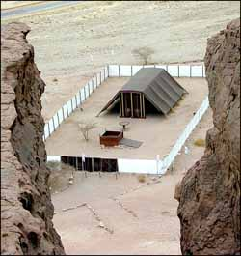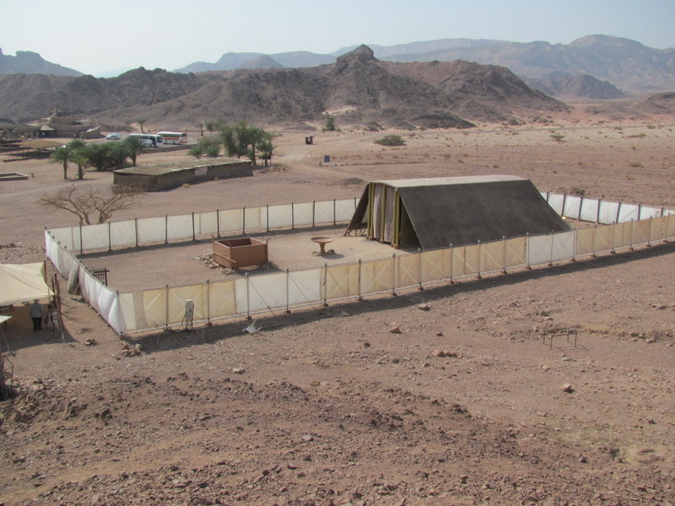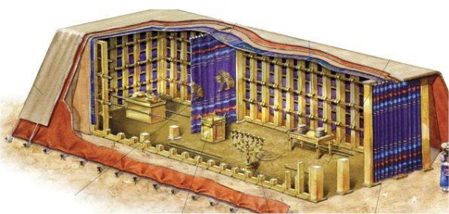
Notice how plain the appearance of the tabernacle is from the outside. Take note of the plain fabric coverings that form the roof of the tent.
Could this be the meeting place of God? Could this be the place God dwells?

A peek past the curtains reveals the beauty within.

