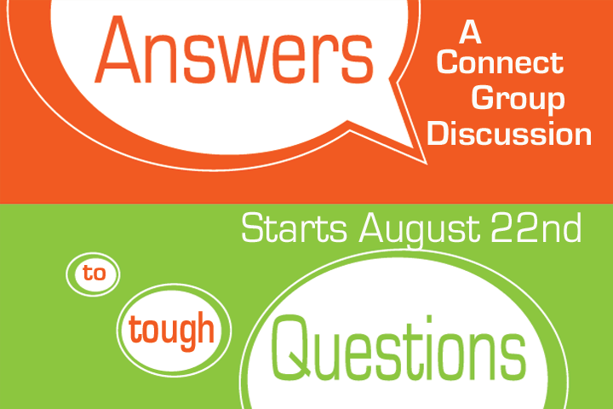

Got a Question? Let’s hear it!



Got a Question? Let’s hear it!



Got a Question? Let’s hear it!



Got a Question? Let’s hear it!



Got a Question? Let’s hear it!



Got a Question? Let’s hear it!